**Semester 2 Examination 2016**

**Question/answer booklet**

Circle your teacher’s initials

JIB MAW MPC SWA VMU

**Mathematics Methods**

**Units 3 & 4**

Section Two

**(Calculator Assumed)**

**Your name**: _________________________________

**Time allowed for this section**

95

Reading time before commencing work: ten minutes

Working time for paper: one hundred minutes

**Materials required/recommended for this section**

***To be provided by the supervisor***

This Question/Answer Booklet

Formula Sheet (retained from Section One)

***To be provided by the candidate***

Standard items:pens (blue/black preferred), pencils (including coloured), sharpener, correction tape/fluid, eraser, ruler, highlighters

Special items: drawing instruments, templates, notes on two unfolded sheets of A4 paper, and up to three calculators approved for use in this examination

**Important note to candidates**

No other items may be taken into the examination room. It is your responsibility to ensure that you do not have any unauthorised notes or other items of a non-personal nature in the examination room. If you have any unauthorised material with you, hand it to the supervisor before reading any further.

**Structure of this paper**

|  |  |  |  |  |  |
| --- | --- | --- | --- | --- | --- |
| Section | Number of questions available | Number of questions to be answered | Working time (minutes) | Marks available | Percentage of exam |
| Section One:  Calculator-free | 8 | 8 | 50 | 52 | 35 |
| **Section Two:**  **Calculator-assumed** | **12** | **12** | **100** | **95** | **65** |
|  |  |  |  | **Total** | 100 |

**Instructions to candidates**

1. The rules for the conduct of Western Australian external examinations are detailed in the *Year 12 Information Handbook 2016.* Sitting this examination implies that you agree to abide by these rules.

2. Write your answers in the spaces provided in this Question/Answer Booklet. Spare pages are included at the end of this booklet. They can be used for planning your responses and/or as additional space if required to continue an answer.

• Planning: If you use the spare pages for planning, indicate this clearly at the top of

the page.

• Continuing an answer: If you need to use the space to continue an answer, indicate in the original answer space where the answer is continued, i.e. give the page number.

Fill in the number of the question(s) that you are continuing to answer at the top of the page.

3. **Show all your working clearly.** Your working should be in sufficient detail to allow your answers to be checked readily and for marks to be awarded for reasoning. Incorrect answers given without supporting reasoning cannot be allocated any marks. For any question or part question worth more than two marks, valid working or justification is required to receive full marks. If you repeat an answer to any question, ensure that you cancel the answer you do not wish to have marked.

4. It is recommended that you **do not use pencil**, except in diagrams.

5. The Formula Sheet is **not** handed in with your Question/Answer Booklet.

**Question 9 (9 marks)**

The velocity of a particle is given by  m/sec.

a) Determine the instantaneous rate of change of velocity at . (2 marks)

b) Using the small changes technique, obtain an estimate for the change in velocity from  to  seconds. (3 marks)

c) Determine the average rate of change of velocity for the period of time from

 to . (2 marks)

d) Calculate, correct to the nearest 0.01 metres, the change in displacement, from  to seconds. (2 marks)

**Question 10 (12 marks)**

James, a second hand car sales manager, realises that 6% of the vehicles for sale in his yards are defective in some minor way. He is prepared to fix all defects but only if the customer returns with a problem. Assume all customers with a problem return for assistance and that X, representing the number of vehicles returned for repairs per month, is a binomial random variable.

1. Determine the probability that if 21 cars are sold during the month:
   1. none will be returned.

(2 marks)

* 1. no more than three will be returned.

(2 marks)

* 1. no more than three will be returned if one has already been returned.

(2 marks)

**Question 10 (cont.)**

1. What is the maximum number of cars that they can sell so the probability that at most 5 vehicles are returned is greater than 0.99?

(3 marks)

1. Jenny, a sales manager at James’ main competitor, has a similar problem. You are given that the expected number of vehicles returned for repairs per month is 2.03 and that this can be modelled by a binomial random variable with a variance of 1.8879. Calculate how many cars she sold during the month and what proportion of them have defects.

(3 marks)

**Question 11 (8 marks)**

A random survey was conducted to estimate the proportion of WA voters who preferred the Liberal Party or Labor Party for the upcoming state election. It was found that 340 out of 638 people surveyed preferred the Labor Party.

a) Determine a point estimate for  of those who preferred the Labor Party.

(1 mark)

b) Use  to calculate an 80% confidence interval for .

(3 marks)

c) A second sample consisting of 300 people provided a confidence interval of . Determine the point estimate for  in this sample and the level of confidence for this interval.

(4 marks)

**Question 12 (5 marks)**

A new type of rowing oar is to be tested. The shape of the blade is as shown shaded in the diagram below.

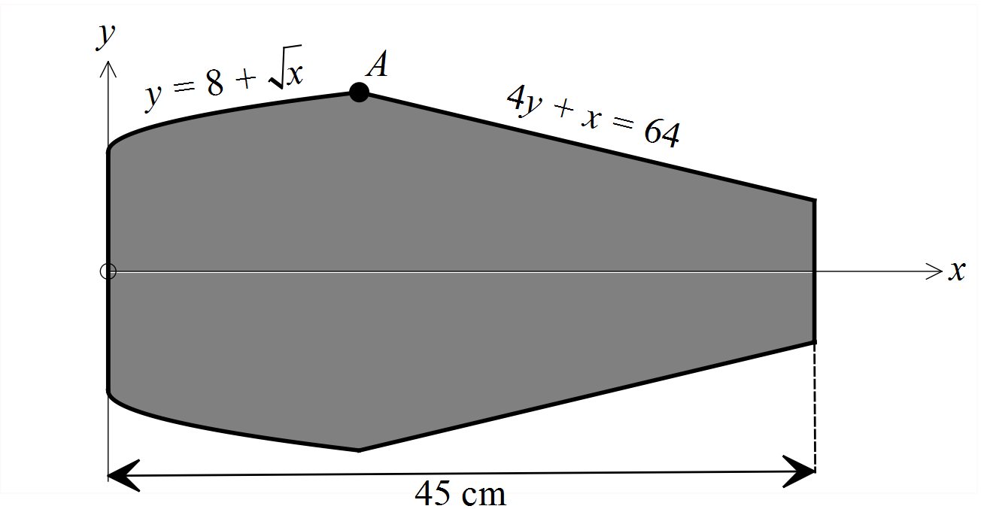

The y-axis forms the left hand boundary, the x-axis is a line of symmetry and

1 cm = 1 unit on each axis. Point A is where the equations  and 

meet.

a) Determine the coordinates of point A.

(1 mark)

b) Hence, or otherwise, determine the shaded area correct to the nearest square centimetre.

(4 marks)

**Question 13 (5 marks)**

Iodine-131 is present in radioactive waste from the nuclear power industry.

It has a half-life of eight days. This means that every eight days, one half of the iodine-131 decays to a form that is not radioactive.

This decay can be represented by the equation ,

where  = amount of iodine-131 present after *t* days, and

= amount of iodine-131 present initially.

a) Determine the value of *k* correct to three decimal places. (3 marks)

b) If 125 milligrams of iodine-131 are considered to be safe, how many complete days will it take for 78 grams of iodine-131 to decay to a safe amount.

(2 marks)

**Question 14 (9 marks)**

The owners of a chain of discount camping stores plan to open a new shop in Osborne Park. To gauge interest in such a store, they randomly selected 650 people in the area and surveyed them. 390 people were in favour of the new store.

a) Calculate the sample proportion of people who were in favour of the new store.

(1 mark)

b) (i) Use the sample proportion calculated in part a) to determine the 95%

confidence interval for the population proportion.

(2 marks)

(ii) Interpret the meaning of the confidence interval determined in part b)(i).

(2 marks)

(iii) State the margin of error of the confidence interval determined in part b)(i).

(1 mark)

c) Use the sample proportion calculated in part a) to determine the sample size required to establish the proportion of within 2% for the 95% confidence interval.

(3 marks)

**Question 15 (7 marks)**

In Australia, size 10 shoes should be between 27.4 cm and 27.8 cm in length. A shoe manufacturer has calculated that its machinery, when set to size 10, produces shoes that are normally distributed with a mean of 27.62 cm and a standard deviation of 0.115 cm.

a) What percentage of shoes produced will be within the size 10 range? (2 marks)

b) To test the operation of the machine, ten shoes are randomly selected each hour.

If two or more are found to be outside the acceptable range, the machine is serviced. What is the probability that a service will be necessary? (3 marks)

c) The manufacturer would prefer that 95% of the shoes produced be within the

acceptable range. To achieve this, the machine will be adjusted to have a normal distribution with a mean of 27.6 cm and a new standard deviation. What standard deviation will be required? (2 marks)

**Question 16 (7 marks)**

The thickness *x* (in microns) of a protective coating applied to a conductor designed to work in corrosive conditions is known to follow a uniform distribution in the interval .

a) State the probability density function  for the random variable *X*.

(2 marks)

b) Determine the probability that the thickness of the protective coating is

exactly 25 microns.

(1 mark)

c) Determine the probability that the thickness of the protective coating is less than 36 microns thick given that it is at least 28 microns thick.

(2 marks)

d) Determine the cumulative distribution function  of the thickness of the protective coating.

(2 marks)

**Question 17 (8 marks)**

The acceleration, ms-2, of an object moving in a straight line is given by

, where *A* and *B* are non-zero constants.

The velocity-time graph of the object is given below.

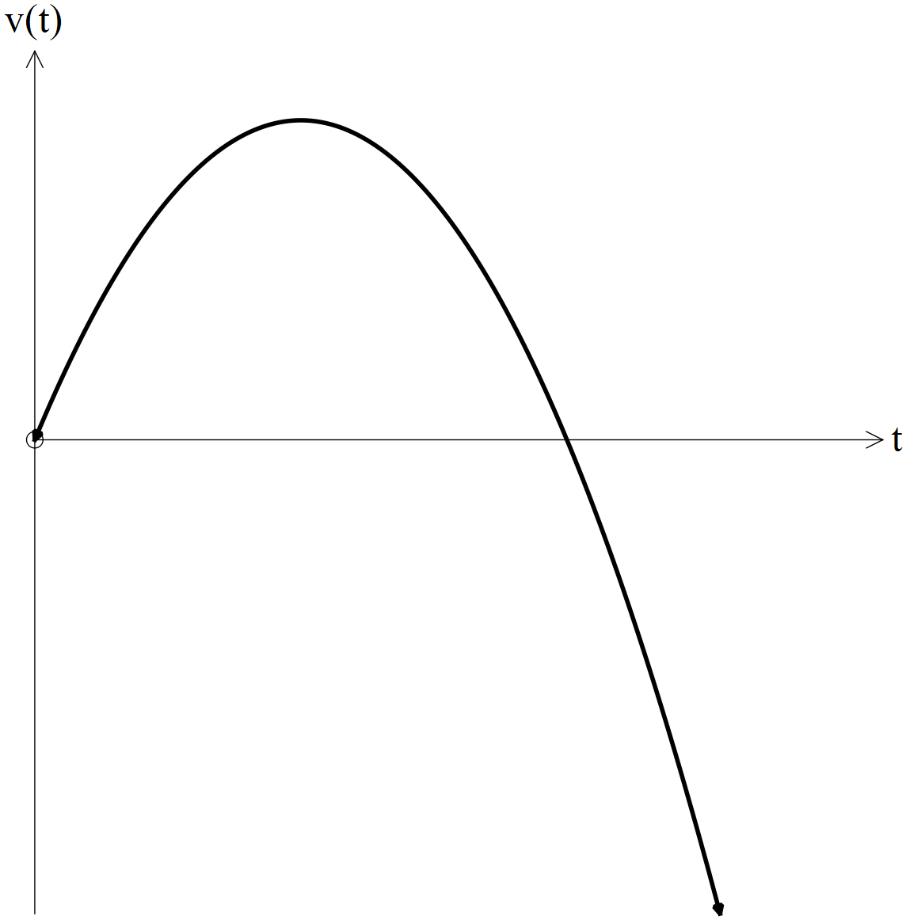

a) (i) Given the object is initially at rest, determine the velocity of the particle in

terms of A, B and t.

(2 marks)

(ii) Given the object is again at rest after 10 seconds, use your velocity function from part a)(i) to determine B in terms of A.

(1 mark)

**Question 17 (cont.)**

b) If the object returns to its initial position after T seconds, determine T .

(2 marks)

c) Evaluate *A* and *B*, given that the acceleration is positive initially and that the

object travels a distance of 1000 metres in the first 15 seconds. (3 marks)

**Question 18 (9 marks)**

The probability density function of *X* is given by:



a) Determine the value of *a*. (1 mark)

b) Sketch the graph of  for , labelling all key features.

(2 marks)

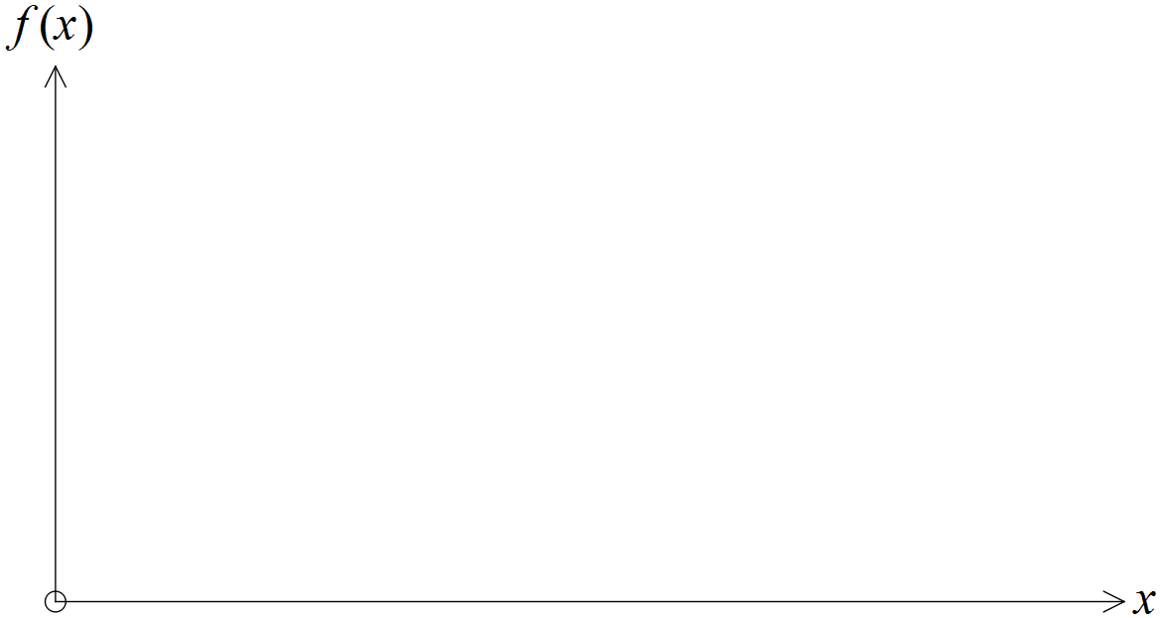

**Question 18 (cont.)**

c) Determine the median and the upper quartile of X.

(3 marks)

d) Determine the mean and variance of X.

(3 marks)

**Question 19 (8 marks)**

The mean  and standard deviation  of the uniform distribution on the interval ** are given by:



A calculator can generate random numbers that are uniformly distributed between 0 and 1.

a) For this distribution of the random numbers generated by the calculator, calculate:

(i) the mean (1 mark)

(ii) the standard deviation (correct to three decimal places). (1 mark)

b) What is the probability that a randomly-generated number lies between and ?

(1 mark)

c) What is the probability that a randomly-generated number contains no eight in its first six decimal places? (1 mark)

**Question 19 (cont.)**

d) What is the probability that a randomly-generated number contains at most three odd digits in its first six decimal places? Give your answer to four decimal places. (2 marks)

e) Another uniform distribution on an interval  has a standard deviation of . How wide is the interval?

(2 marks)

**Question 20 (8 marks)**

The cross-section of a storm drain is to be an isosceles trapezium, with three sides of length 2 metres, as shown.

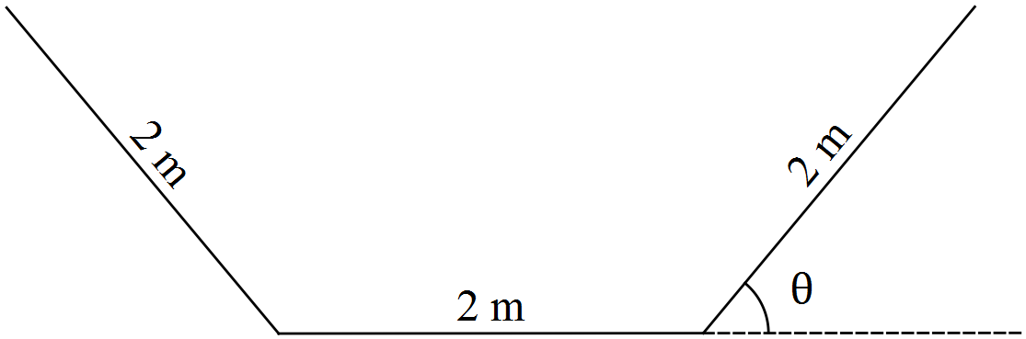

a) Show that the area of the trapezium is given by .

(3 marks)

**Question 20 (cont.)**

b) Use a calculus method to determine the angle  which maximises the cross-sectional area and hence find this maximum area. (5 marks)

**END OF SECTION TWO**

**Additional Working Space**

Question Number:___________